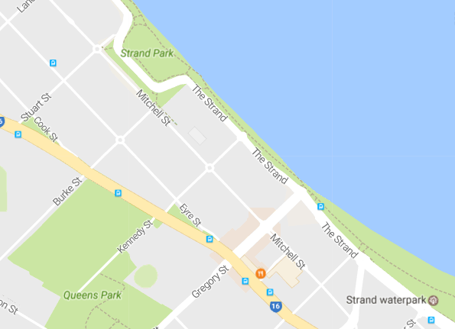

Pokemund St

**Slammers Beach Volleyball**

123 Pokemund Street, Cairsville QLD 4755 Phone: 47712233 email: slammers@gmail.com

